IT STAFFING
The objective of the system is to automate the recruitment screening process by analyzing resumes submitted by candidates and matching them with job descriptions posted by employers.
Employer
│
│ (Job Description)
▼
Job Description Processing
│
▼
Skill & Requirement Extraction
│
│
Candidate Upload Resume (PDF)
│
▼
Resume Processing
(PDF Parsing + Text Extraction)
│
▼
Skill & Experience Extraction
│
▼
Matching Engine
(JD Skills vs Resume Skills)
│
▼
Weighted Scoring Engine
(Skills + Experience Score)
│
▼
Candidate Ranking
│
▼
Dashboard / UI
(Ranked Candidate List)

Responsibilities:
- Allow recruiters to enter Job Description
- Allow candidates/resumes to be uploaded
- Display analysis results
- Show ranked candidate list

Workflow
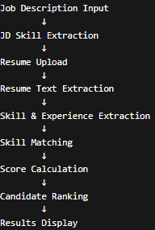
Step 1: Job Description Input
Step 2: Job Description Processing
Step 3: Resume Upload
Step 4: Resume Parsing
Step 5: Resume Information Extraction
Step 6: Skill Matching
Step 7: Skill Score Calculation
Step 8: Final Candidate Score

